Codebook for sec_car

Autogenerated data summary from dataMaid

2021-09-23 21:59:43

# Data report overview

The dataset examined has the following dimensions:

|  |  |
| --- | --- |
| Feature | Result |
| Number of observations | 300000 |
| Number of variables | 10 |

# Codebook summary table

|  |  |  |  |  |  |
| --- | --- | --- | --- | --- | --- |
| Label | Variable | Class | # unique values | Missing | Description |
|  | **maker** | factor | 3 | 0.00 % |  |
|  | **model** | factor | 105 | 0.00 % |  |
|  | **mileage** | numeric | 67879 | 0.00 % |  |
|  | **manufacture_year** | numeric | 123 | 0.00 % |  |
|  | **transmission** | factor | 2 | 0.00 % |  |
|  | **door_count** | factor | 15 | 0.00 % |  |
|  | **seat_count** | factor | 33 | 0.00 % |  |
|  | **displacement** | numeric | 407 | 0.00 % |  |
|  | **horse_power** | numeric | 341 | 0.00 % |  |
|  | **price** | numeric | 32322 | 0.00 % |  |

# Variable list

## maker

|  |  |
| --- | --- |
| Feature | Result |
| Variable type | factor |
| Number of missing obs. | 0 (0 %) |
| Number of unique values | 3 |
| Mode | “audi” |
| Reference category | audi |

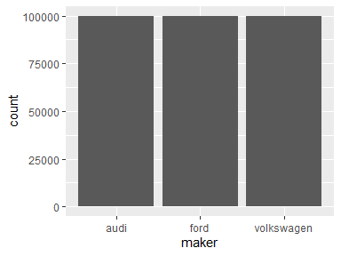

* Observed factor levels: "audi", "ford", "volkswagen".

## model

|  |  |
| --- | --- |
| Feature | Result |
| Variable type | factor |
| Number of missing obs. | 0 (0 %) |
| Number of unique values | 105 |
| Mode | “golf” |
| Reference category | 100 |

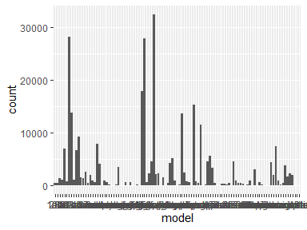

* Observed factor levels: "100", "200", "80", "90", "a1", "a2", "a3", "a4", "a4-allroad", "a5", "a6", "a6-allroad", "a7", "a8", "amarok", "b-max", "beetle", "bora", "c-max", "caddy", "capri", "caravelle", "cc", "connect", "contour", "corrado", "cougar", "coupe", "crown-victoria", "edge", "eos", "escape", "escort", "excursion", "expedition", "explorer", "f-150", "fiesta", "focus", "fox", "fusion", "galaxy", "golf", "golf-plus", "golf-sportsvan", "granada", "grand-c-max", "gt", "jetta", "ka", "kuga", "lupo", "marauder", "maverick", "mondeo", "multivan", "mustang", "new-beetle", "orion", "passat", "passat-cc", "phaeton", "polo", "probe", "puma", "q3", "q5", "q7", "r8", "routan", "rs2", "rs3", "rs4", "rs5", "rs6", "rs7", "s-max", "s3", "s4", "s5", "s6", "s7", "s8", "scirocco", "scorpio", "sharan", "sierra", "sq5", "streetka", "taunus", "taurus", "thunderbird", "tiguan", "touareg", "touran", "tourneo-connect", "tourneo-courier", "tourneo-custom", "transit", "transporter", "tt", "up", "v8", "vento", "windstar".

## mileage

|  |  |
| --- | --- |
| Feature | Result |
| Variable type | numeric |
| Number of missing obs. | 0 (0 %) |
| Number of unique values | 67879 |
| Median | 55914 |
| 1st and 3rd quartiles | 15992; 96934 |
| Min. and max. | 0; 6213709 |

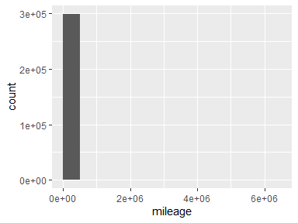

## manufacture_year

|  |  |
| --- | --- |
| Feature | Result |
| Variable type | numeric |
| Number of missing obs. | 0 (0 %) |
| Number of unique values | 123 |
| Median | 2011 |
| 1st and 3rd quartiles | 2006; 2014 |
| Min. and max. | 39; 2017 |

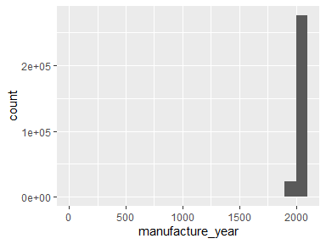

## transmission

|  |  |
| --- | --- |
| Feature | Result |
| Variable type | factor |
| Number of missing obs. | 0 (0 %) |
| Number of unique values | 2 |
| Mode | “man” |
| Reference category | auto |

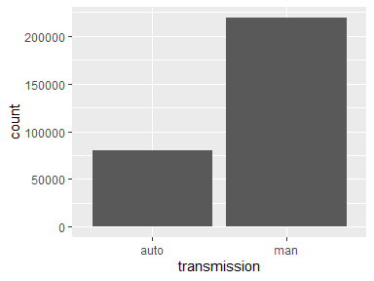

* Observed factor levels: "auto", "man".

## door_count

|  |  |
| --- | --- |
| Feature | Result |
| Variable type | factor |
| Number of missing obs. | 0 (0 %) |
| Number of unique values | 15 |
| Mode | “5.0” |
| Reference category | 1 |

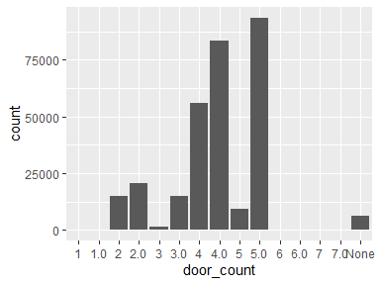

* Observed factor levels: "1", "1.0", "2", "2.0", "3", "3.0", "4", "4.0", "5", "5.0", "6", "6.0", "7", "7.0", "None".

## seat_count

|  |  |
| --- | --- |
| Feature | Result |
| Variable type | factor |
| Number of missing obs. | 0 (0 %) |
| Number of unique values | 33 |
| Mode | “5.0” |
| Reference category | 1 |

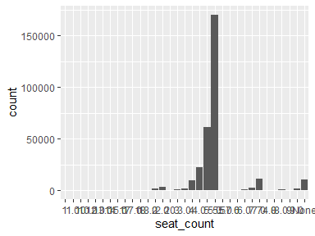

* Observed factor levels: "1", "1.0", "10", "10.0", "12.0", "13.0", "14", "15.0", "17", "17.0", "18", "18.0", "2", "2.0", "20", "3", "3.0", "4", "4.0", "5", "5.0", "55.0", "57.0", "6", "6.0", "7", "7.0", "74.0", "8", "8.0", "9", "9.0", "None".

## displacement

|  |  |
| --- | --- |
| Feature | Result |
| Variable type | numeric |
| Number of missing obs. | 0 (0 %) |
| Number of unique values | 407 |
| Median | 1.9 |
| 1st and 3rd quartiles | 1.56; 1.98 |
| Min. and max. | 0.01; 32.77 |

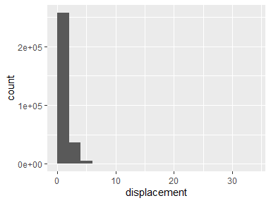

## horse_power

|  |  |
| --- | --- |
| Feature | Result |
| Variable type | numeric |
| Number of missing obs. | 0 (0 %) |
| Number of unique values | 341 |
| Median | 123 |
| 1st and 3rd quartiles | 101; 154 |
| Min. and max. | 13; 1337 |

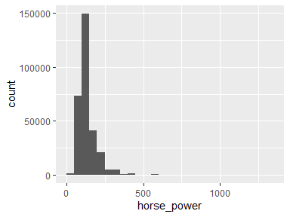

## price

|  |  |
| --- | --- |
| Feature | Result |
| Variable type | numeric |
| Number of missing obs. | 0 (0 %) |
| Number of unique values | 32322 |
| Median | 13455 |
| 1st and 3rd quartiles | 4797; 23271 |
| Min. and max. | 0; 30420000 |

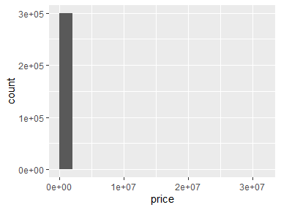

Report generation information:

* Created by: Could not determine from system (username: Unknown)
* Report creation time: Thu Sep 23 2021 21:59:49
* Report was run from directory: C:/Users/hanna/OneDrive/Desktop/BBDS Batch 14/13. Secondary Car Market
* dataMaid v1.4.0 [Pkg: 2019-12-10 from CRAN (R 3.6.3)]
* R version 3.6.3 (2020-02-29).
* Platform: x86_64-w64-mingw32/x64 (64-bit)(Windows 10 x64 (build 19043)).
* Function call: dataMaid::makeDataReport(data = sec_car, mode = c("summarize", "visualize", "check"), smartNum = FALSE, file = "codebook_sec_car.Rmd", checks = list(character = "showAllFactorLevels", factor = "showAllFactorLevels", labelled = "showAllFactorLevels", haven_labelled = "showAllFactorLevels", numeric = NULL, integer = NULL, logical = NULL, Date = NULL), listChecks = FALSE, maxProbVals = Inf, codebook = TRUE, reportTitle = "Codebook for sec_car")